
School Education & Literacy Department, Government of Sindh
RFP-6, Package-1, District Karachi Schools being managed by
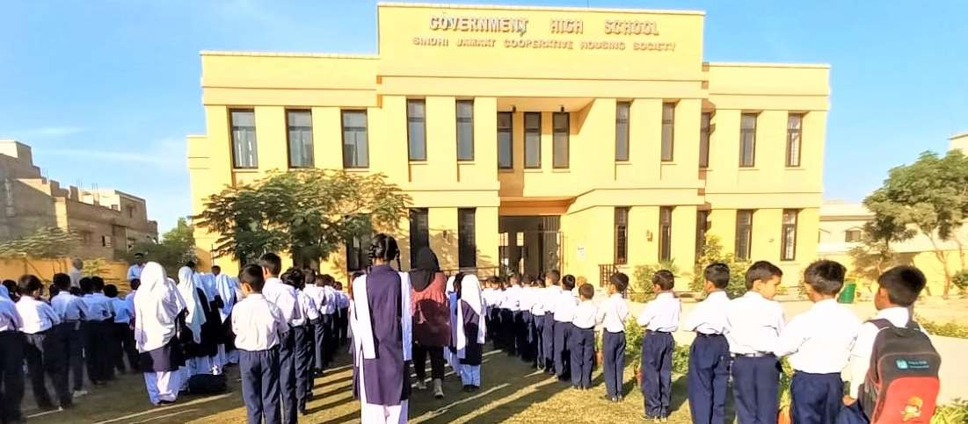
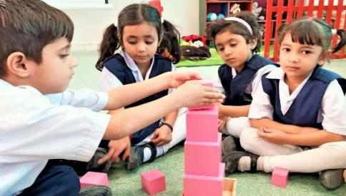
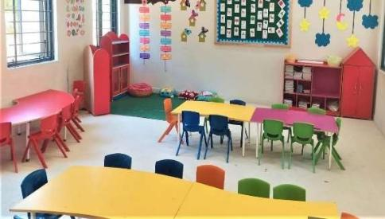
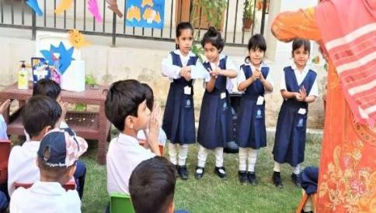
Sindh Madressah-tul-Islam Board
Quarterly KPIs Progress Report
Period of Performance:November 17, 2024 – February 16, 2025


Submitted by:

Sindh Madressah-tul-Islam Board
(Educational Management Organization)

To:

Teacher Resource Center
(Independent Expert)

KPI 2: Improved Staff Availability and Attendance

Availability of Staff
Details of teacher availability for each school are provided in the table below.
Teaching Staff Available in Schools
School Name |  | Government / Private |  |  |  | Teaching / Non- Teaching |  |  | Subjects / Department |  |  |  | Categories (SST, ST, PST, etc.) |  |  |  |  | Active (regular) |  |  | Transfer In |  |  |  | Deputation |  |  | New Hiring |  | Total
GBPS Sindhi Jamaat Cooperative Housing Society |  | Govt/Private |  |  |  | Teaching |  |  |  |  |  |  | HSTs= 1  JSTs= 1  JESTs=  ECT= 1  O.T=  PET=  SLT=  WI=  ITT=  PST= 9  Private= 8 |  |  |  |  | 20 |  |  | 0 |  |  |  | 1 |  |  | 4 |  | 20
GBPS Haji Shafi Muhammad Goth |  | Govt/Private |  |  |  | Teaching |  |  |  |  |  |  | HSTs= 0  JSTs= 0  JESTs= 0  ECT= 0  O.T= 0  PET= 0  SLT= 0  WI= 0  ITT=0  PST=5  Private =0 |  |  |  |  | 5 |  |  | 0 |  |  |  | 0 |  |  | 0 |  | 5
GBPS Master Allahna Muhammad Hassan Panhwer Goth |  | Govt/Private |  |  |  | Teaching |  |  |  |  |  |  | HSTs= 0  JSTs= 0  JESTs= 0  ECT= 1  O.T= 0  PET= 0  SLT= 0  WI= 0  ITT=0  PST=7  Private= 0 |  |  |  |  | 8 |  |  | 0 |  |  |  | 0 |  |  | 0 |  | 8
GBPS Juvinail Jail near Quaidabad Bin Qasim Town |  | Govt/Private |  |  |  | Teaching |  |  |  |  |  |  | HSTs= 0  JSTs= 0  JESTs= 0  ECT= 0  O.T= 0  PET= 0  SLT= 0  WI= 0  ITT=0  PST=3  Private 0 |  |  |  |  | 3 |  |  | 0 |  |  |  | 0 |  |  | 0 |  | 3
Details of availability of non-teaching staff for each school are provided in the table below.
Non-Teaching Staff Available in School
School Name |  | Government / Private |  |  |  | Teaching / Non- Teaching |  |  | Subjects / Department |  |  |  | Categories (SST, ST, PST, etc.) |  |  |  |  | Active (regular) |  |  | Transfer In |  |  |  | Deputation |  |  | New Hiring |  | Total
GBPS Sindhi Jamaat Cooperative Housing Society |  | Govt/Private |  |  |  | Non-Teaching |  |  | Primary |  |  |  | Govt= 1  Private= 8 |  |  |  |  | 9 |  |  | 0 |  |  |  | 0 |  |  | 0 |  | 9
GBPS Haji Shafi Muhammad Goth |  | Govt/Private |  |  |  | Non-Teaching |  |  | Primary |  |  |  | Govt= 1  Private= 0 |  |  |  |  | 1 |  |  | 0 |  |  |  | 0 |  |  | 0 |  | 1
GBPS Master Allahna Muhammad Hassan Panhwer Goth |  | Govt/Private |  |  |  | Non-Teaching |  |  | Primary |  |  |  | Govt= 1  Private= 0 |  |  |  |  | 1 |  |  | 0 |  |  |  | 0 |  |  | 0 |  | 1
GBPS Juvinail Jail near Quaidabad Bin Qasim Town |  | Govt/Private |  |  |  | Non-Teaching |  |  | Primary |  |  |  | Govt= 2  Private= 0 |  |  |  |  | 2 |  |  | 0 |  |  |  | 0 |  |  | 0 |  | 2
Staff Leaves Status
Teaching Staff |  |  |  |  |  |  |  |  |  |  |  |  |  |  | Non-Teaching Staff
School Name |  |  | Type of Leaves |  |  |  |  | No. of staff |  |  |  |  |  |  | Type of Leaves |  |  |  |  |  |  |  | No. of staff
GBPS Sindhi Jamaat Cooperative Housing Society |  |  | Casual Leave |  |  |  |  | 10 |  |  |  |  |  |  | Casual Leave |  |  |  |  |  |  |  | 3
 |  |  | Medical Leave |  |  |  |  | 45 |  |  |  |  |  |  | Medical Leave
 |  |  | Annual Leave |  |  |  |  |  |  |  |  |  |  |  | Annual Leave
GBPS Haji Shafi Muhammad Goth |  |  | Casual Leave |  |  |  |  |  |  |  |  |  |  |  | Casual Leave
 |  |  | Medical Leave |  |  |  |  |  |  |  |  |  |  |  | Medical Leave
 |  |  | Annual Leave |  |  |  |  |  |  |  |  |  |  |  | Annual Leave
GBPS Master Allahna Muhammad Hassan Panhwer Goth |  |  | Casual Leave |  |  |  |  |  |  |  |  |  |  |  | Casual Leave
 |  |  | Medical Leave |  |  |  |  |  |  |  |  |  |  |  | Medical Leave
 |  |  | Annual Leave |  |  |  |  |  |  |  |  |  |  |  | Annual Leave
GBPS Juvinail Jail near Quaidabad Bin Qasim Town |  |  | Casual Leave |  |  |  |  |  |  |  |  |  |  |  | Casual Leave
 |  |  | Medical Leave |  |  |  |  |  |  |  |  |  |  |  | Medical Leave
 |  |  | Annual Leave |  |  |  |  |  |  |  |  |  |  |  | Annual Leave
Student Teacher Ratio (STR)
School Name |  |  |  |  |  |  |  |  |  |  |  |  |  |  |  | Class / Grade |  |  |  |  |  |  |  | STR
GBPS Sindhi Jamaat Cooperative Housing Society |  |  |  |  |  |  |  |  |  |  |  |  |  |  |  | ECE to IX |  |  |  |  |  |  |  | 27:1
GBPS Haji Shafi Muhammad Goth |  |  |  |  |  |  |  |  |  |  |  |  |  |  |  | ECE to V |  |  |  |  |  |  |  | 47:1
GBPS Master Allahna Muhammad Hassan Panhwer Goth |  |  |  |  |  |  |  |  |  |  |  |  |  |  |  | ECE to V |  |  |  |  |  |  |  | 67:1
GBPS Juvinail Jail near Quaidabad Bin Qasim Town |  |  |  |  |  |  |  |  |  |  |  |  |  |  |  | ECE to V |  |  |  |  |  |  |  | 36:1

Functional Attendance Management

Staff Attendance
- School Name GBPS Sindhi Jamaat Cooperative Housing Society
- Baseline Attendance: 98%
- Previous Quarter: 98%
- Current Attendance: 95%
- Analysis: Attendance has been consistently high, with a negligible decrease of 2%. The school has maintained an almost perfect attendance rate.
- School Name GBPS Haji Shafi Muhammad Goth
- Baseline Attendance: 95%
- Previous Quarter: 95%
- Current Attendance: 90%
- Analysis:
- School Name
- Baseline Attendance:
- Previous Quarter:
- Current Attendance:
- Analysis:
- School Name
- Baseline Attendance:
- Previous Quarter:
- Current Attendance:
- Analysis:

Teaching Staff Attendance Percentage
School Name |  |  |  |  | Month |  |  |  |  |  | Baseline Attendance |  |  |  |  |  |  |  | Attendance in the previous quarter |  |  |  |  |  |  | Current Attendance
GBPS Sindhi Jamaat Cooperative Housing Society |  |  |  |  | Nov 2024 to Feb 2025 |  |  |  |  |  | 100% |  |  |  |  |  |  |  | 98% |  |  |  |  |  |  | 90%
GBPS Haji Shafi Muhammad Goth |  |  |  |  | Nov 2024 to Feb 2025 |  |  |  |  |  | 82% |  |  |  |  |  |  |  | 94% |  |  |  |  |  |  | 85%
GBPS Master Allahna Muhammad Hassan Panhwer Goth |  |  |  |  | Nov 2024 to Feb 2025 |  |  |  |  |  | 82% |  |  |  |  |  |  |  | 94% |  |  |  |  |  |  | 85%
GBPS Juvinail Jail near Quaidabad Bin Qasim Town |  |  |  |  | Nov 2024 to Feb 2025 |  |  |  |  |  | 82% |  |  |  |  |  |  |  | 94% |  |  |  |  |  |  | 85%
Analysis of Non-Teaching Staff Attendance for the reporting quarter in comparison with the previous quarter and baseline data.
- School Name
- Baseline Attendance:
- Previous Quarter:
- Current Attendance:
- Analysis:
- School Name
- Baseline Attendance:
- Previous Quarter:
- Current Attendance:
- Analysis:
- School Name
- Baseline Attendance:
- Previous Quarter:
- Current Attendance:
- Analysis:
- School Name
- Baseline Attendance:
- Previous Quarter:
- Current Attendance:
- Analysis:

Non-Teaching Staff Attendance Percentage
School Name |  |  |  |  | Month |  |  |  |  |  | Baseline Attendance |  |  |  |  |  |  |  | Attendance in the previous quarter |  |  |  |  |  |  | Current Attendance
GBPS Sindhi Jamaat Cooperative Housing Society
GBPS Haji Shafi Muhammad Goth
GBPS Master Allahna Muhammad Hassan Panhwer Goth
GBPS Juvinail Jail near Quaidabad Bin Qasim Town

KPI 3: Improved Student Enrolment, Attendance, and Retention

Student Enrolment, Attendance Management, and Retention Plan
Status of Activities Planned for the Quarter based on Student Enrolment,
Attendance Management, and Retention Plan
School Name |  |  |  |  | Month |  |  |  |  |  | Planned Activity |  |  |  |  |  |  |  | Status of Activity |  |  |  |  |  |  | Reason for Delay (If Applicable)
GBPS Sindhi Jamaat Cooperative Housing Society |  |  |  |  | Nov-24 |  |  |  |  |  | Children’s Day |  |  |  |  |  |  |  | Done
 |  |  |  |  | Nov-24 |  |  |  |  |  | Sindhi Culture Day |  |  |  |  |  |  |  | Done
 |  |  |  |  | Dec-24 |  |  |  |  |  | Student / Sports Week |  |  |  |  |  |  |  | Done
 |  |  |  |  | Jan-25 |  |  |  |  |  | PTM |  |  |  |  |  |  |  | Done
 |  |  |  |  | Jan-25 |  |  |  |  |  | Winter Day Celebration |  |  |  |  |  |  |  | Done
 |  |  |  |  | Feb-25 |  |  |  |  |  | Colours Day |  |  |  |  |  |  |  | Done
GBPS Haji Shafi Muhammad Goth
GBPS Master Allahna Muhammad Hassan Panhwer Goth
GBPS Juvinail Jail near Quaidabad Bin Qasim Town

Improvement in Student Enrolment, Attendance Management, and Retention Rates
Enrollment Status of _____________________________________
Disaggregated by Gender & Grade
Grade | Initial baseline (at time of handing over) |  |  |  |  |  | Current baseline (at start of academic year) |  |  |  |  | Current enrolment (at the end of reporting period) |  |  |  |  |  |  |  | Percentage of improvement (from initial baseline) |  |  |  |  |  |  | Percentage of improvement (from current baseline)
 | Girls |  |  | Boys |  |  | Girls |  |  | Boys |  | Girls |  |  |  |  | Boys |  |  | Girls |  | Boys |  |  |  |  | Girls |  | Boys
ECE
I
II
III
IV
V
VI
VII
VIII
IX
Enrollment Status of _____________________________________
Disaggregated by Gender & Grade
Grade | Initial baseline (at time of handing over) |  |  |  |  |  | Current baseline (at start of academic year) |  |  |  |  | Current enrolment (at the end of reporting period) |  |  |  |  |  |  |  | Percentage of improvement (from initial baseline) |  |  |  |  |  |  | Percentage of improvement (from current baseline)
 | Girls |  |  | Boys |  |  | Girls |  |  | Boys |  | Girls |  |  |  |  | Boys |  |  | Girls |  | Boys |  |  |  |  | Girls |  | Boys
ECE
I
II
III
IV
V
Enrollment Status of _____________________________________
Disaggregated by Gender & Grade
Grade | Initial baseline (at time of handing over) |  |  |  |  |  | Current baseline (at start of academic year) |  |  |  |  | Current enrolment (at the end of reporting period) |  |  |  |  |  |  |  | Percentage of improvement (from initial baseline) |  |  |  |  |  |  | Percentage of improvement (from current baseline)
 | Girls |  |  | Boys |  |  | Girls |  |  | Boys |  | Girls |  |  |  |  | Boys |  |  | Girls |  | Boys |  |  |  |  | Girls |  | Boys
ECE
I
II
III
IV
V
Enrollment Status of _____________________________________
Disaggregated by Gender & Grade
Grade | Initial baseline (at time of handing over) |  |  |  |  |  | Current baseline (at start of academic year) |  |  |  |  | Current enrolment (at the end of reporting period) |  |  |  |  |  |  |  | Percentage of improvement (from initial baseline) |  |  |  |  |  |  | Percentage of improvement (from current baseline)
 | Girls |  |  | Boys |  |  | Girls |  |  | Boys |  | Girls |  |  |  |  | Boys |  |  | Girls |  | Boys |  |  |  |  | Girls |  | Boys
ECE
I
II
III
IV
V

